1 public class Main

{

public static void main(String[] args) {

String input = "Payal";

byte[] strAsByteArray = input.getBytes();

byte[] result = new byte[strAsByteArray.length];

for (int i = 0; i < strAsByteArray.length; i++)

result[i] = strAsByteArray[strAsByteArray.length - i - 1];

System.out.println(new String(result));

}

}

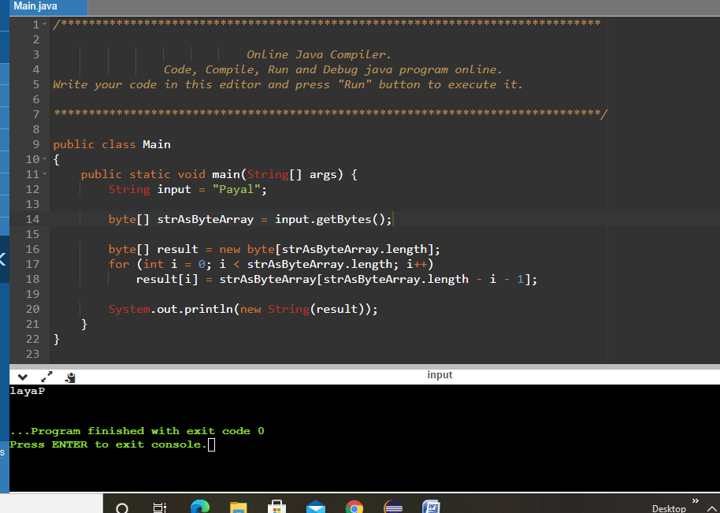

2

import java.io.\*;

import java.lang.\*;

class LessBalanceException extends Exception

{

LessBalanceException(double amt)

{

System.out.println("Withdrawing "+amt+" is invlaid");

}

}

class Account

{

static int count=0;

int accno;

double bal;

String name; Account(double bal,String n,int accno)

{

System.out.println("\nNew Account opened....!!");

this.bal=bal;

count++;

System.out.println("Account Holder Name : " + n);

name=n;

System.out.println("Your Account Number is : "+accno);

this.accno=accno;

System.out.println("Total number of accounts : "+count);

}

void deposit(double amt)

{

System.out.println("Availabe Balance : "+bal);

bal=bal+amt;

System.out.println("Rs. : "+amt+" /- Created");

System.out.println("Balance : "+bal);

}

void withdraw(double amt) throws LessBalanceException

{

System.out.println("\nAvailabe Balance : "+bal);

bal-=amt;

if(bal<500)

{

bal+=amt;

throw new LessBalanceException(amt);

}

System.out.println("Rs. : "+amt+ "/-Debited");

System.out.println("Balacne : "+bal);

}

void balance()

{

System.out.println("\n\*\*\*\*\*\*\*\*\*\*\*\*\*\*\*Customer information\*\*\*\*\*\*\*\*\*\*\*\*\*\*\*\*");

System.out.println("============================================");

System.out.println("Customer Name : "+name);

System.out.println("Account Number : "+accno);

System.out.println("Balance : "+bal);

}

}

class AccountDemo

{

static int i=0;

public static void main(String argv[]) throws IOException

{

Account ob[]=new Account[10];

BufferedReader br=new BufferedReader(new InputStreamReader(System.in));

double amt;

String name;

int ch,accno,k;

boolean t=false;

while(true)

{

System.out.println("\n\*\*\*\*\*\*\* Bank Transaction \*\*\*\*\*\*\*\*\*");

System.out.println("1.Open new Account\n2.Deposit");

System.out.println("3.Withdraw\n4.Balance\n5.Exit");

System.out.print("Enter your choice : ");

ch=Integer.parseInt(br.readLine());

switch(ch)

{

case 1:

System.out.println("Opening New Account : ");

System.out.print("Enter your name : ");

name=br.readLine();

System.out.print("\nEnter Account Number : ");

accno=Integer.parseInt(br.readLine());

System.out.print("\nEnter initial amount(to be >=500) : ");

amt=Double.parseDouble(br.readLine());

if(amt<500)

System.out.println("You cannot create an account with less than Rs.500/-");

else

{

ob[i]=new Account(amt,name,accno);

i++;

}

break;

case 2:

System.out.print("\nEnter Account number : ");

accno=Integer.parseInt(br.readLine());

for(k=0;k<i;k++)

if(accno==ob[k].accno)

{

t=true;

break;

}

if(t)

{

System.out.print("\nEnter the Amount for Deposit : ");

amt=Double.parseDouble(br.readLine());

ob[k].deposit(amt);

}

else

System.out.println("Invalid Account Number...!!!");

t=false;

break;

case 3:

System.out.print("\nEnter Account number : ");

accno=Integer.parseInt(br.readLine());

for(k=0;k<i;k++)

if(accno==ob[k].accno)

{

t=true;

break;

}

if(t)

{

System.out.print("\nEnter the Amount for Withdraw : ");

amt=Double.parseDouble(br.readLine());

try

{

ob[k].withdraw(amt);

}

catch(LessBalanceException e)

{}

}

else

System.out.println("Invalid Account Number...!!!");

t=false;

break;

case 4:

System.out.print("\nEnter Account number : ");

accno=Integer.parseInt(br.readLine());

for(k=0;k<i;k++)

if(accno==ob[k].accno)

{

t=true;

break;

}

if(t)

{

//System.out.println(accno +" asdfsdf " +ob[k].accno);

ob[k].balance();

}

else

System.out.println("Invalid Account Number...!!!");

t=false;

break;

case 5:

System.exit(1);

default: System.out.println("Invalid Choice !!!");

}

}

}